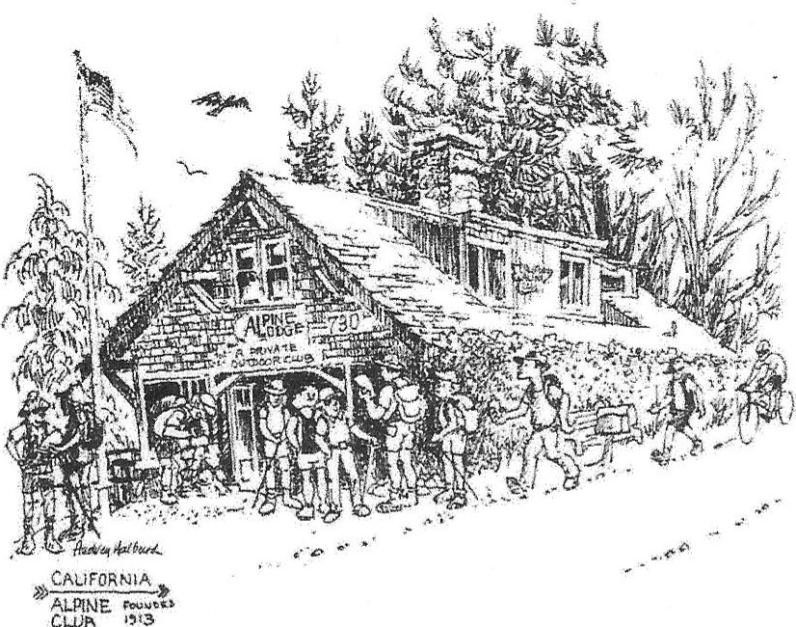 California Alpine Club
CLVb

Date:

To Whom it may concern:

The following member of the California Alpine Club and Trustee of Alpine Lodge, owned and operated by the California Alpine Club, located at 730 Panoramic Highway, Mill Valley Marin County, is authorized to represent the California Alpine Club with respect to the Alpine Lodge and to conduct the normal day-to-day business of operations, maintenance and construction for Alpine Lodge. This authorization includes, but is not limited to, filing applications and permits, signing invoices, signing approved contracts, ordering supplies and paying bills:
Trustee: ________________

This authorization is valid until Trustee's term ends on ______________

Approved:

___________________________ ___________________________
President Trustee

