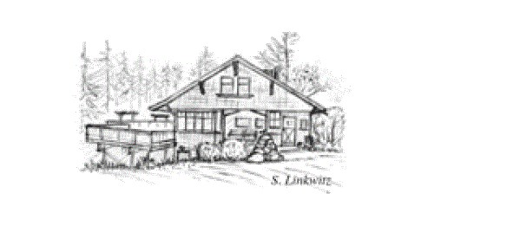
ALPINE LODGE SUNDAY INNKEEPERS

Oct 1 Graham Forder (Overnight Host until 12noon Sunday)
Oct 8 Nancy Emerson and Steve Quarles
Oct 15 Nancy Bisio
Oct 22 Bonnie Herzog
Oct 29 Camille Smith Ballon (Overnight host)
Nov 5 Wendi Olmstead
Nov 12 Nula Caulfield
Nov 19 Bonnie Herzog
Dec 10 Cindi Whitehead
Dec 31 Cindi Whitehead

Volunteers needed. To sign up please contact Wendi
wendiolmstead@comcast.net.

